Module 03 Activity – Create a wireframe of home page

Aline jean Louis Maxi

CIS3801C Section 01 Fundamentals of Mobile Web Application Development

Professor: Kris Jamsa

October 19, 2018

The website is going to be about a business that I intend to do after my graduation as a computer scientist. I will provide users with online services such as: IT management, web design, web development, custom site design, site repair and maintenance, cloud services and etc. The name will be JLMax web-tech services (I already had the domain name: jlmaxwts.com). On the website, users will be able to make a payment, request a ticket, chat with personal support, etc.

Contact page:

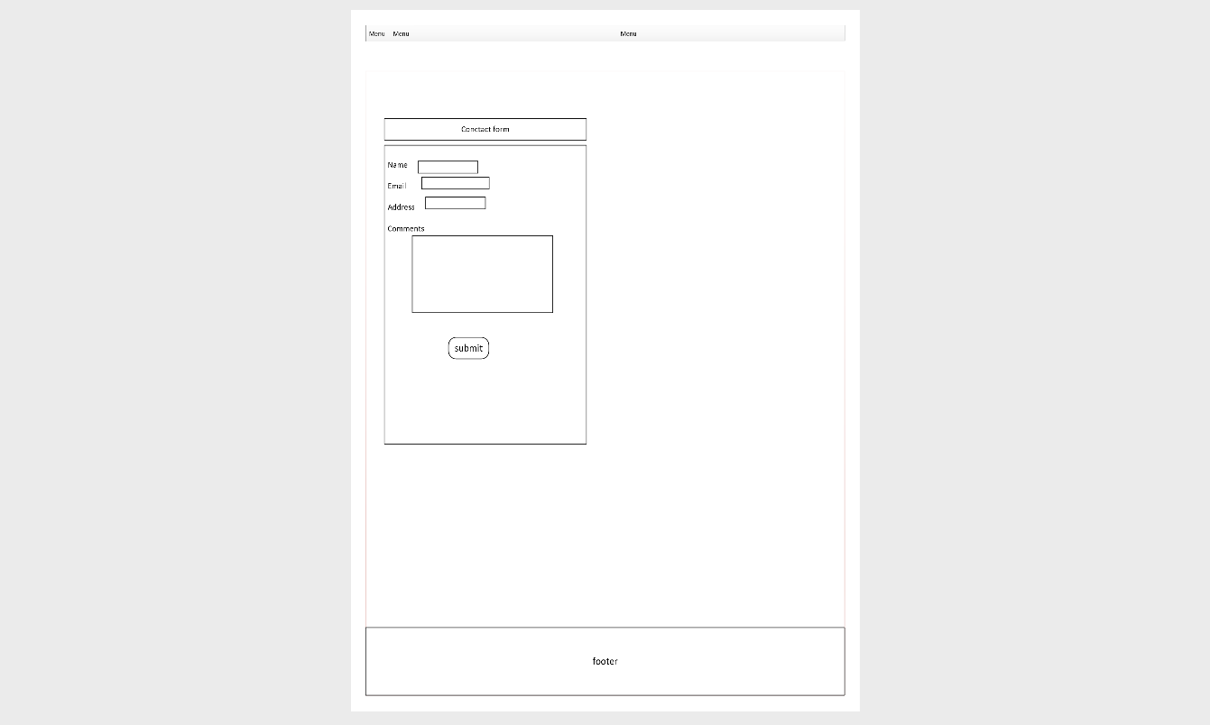

Web development page:

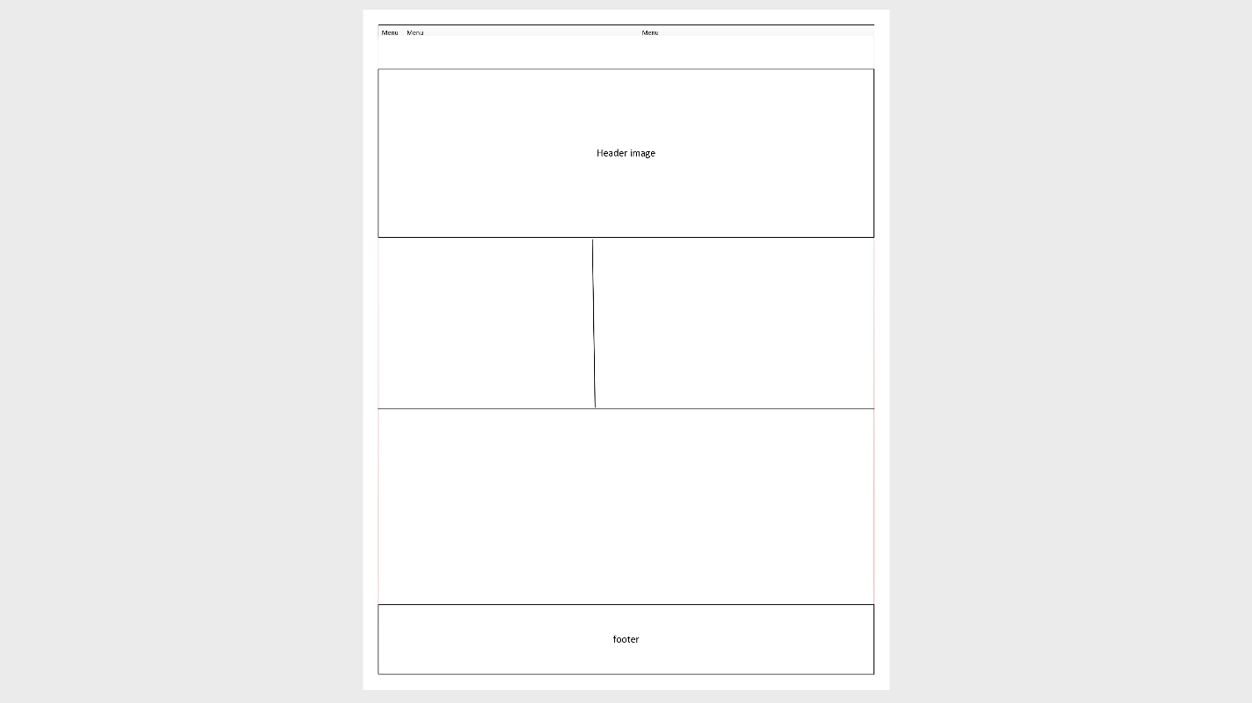

About us

